Management Disclosure and COVID-19

Luc Ginestet-Araki, Wyatt Garrett, Vittorio Reynoso-Avila, and Raul Lemus

**Background**

Every public company must submit reports to the Securities and Exchange Commision (SEC). A company’s flagship annual report, Form 10-K, is made available to the public on the SEC’s EDGAR website. Included in the 10-K document is a management disclosure that discusses potential risk factors to the company including potential health crises. The goal of our capstone project is to understand how management disclosures in 10-K documents might be useful to shareholders and stakeholders of a company. We are interested in seeing how managers discussed pandemic-related risk factors prior to COVID-19 and if the extent to which they discussed risk factors is associated with stock performance after the pandemic. We will compare companies that did disclose pre-pandemic to those that didn’t disclose and see if those companies that did disclose performed better. We will also be comparing by industry to see which industries increased their disclosure and how it affected each industry's performance. To measure performance we will analyze the average Sharpe Ratio change from before the pandemic to after the pandemic by industry and compare the differences between the companies that did disclose and didn’t disclose in each industry. We will also examine whether companies that did disclose had higher alpha, risk adjusted excess return, than companies that did not.

**Data**

To understand the disclosure levels of pandemic related terms before and after the Covid-19 outbreak, we downloaded all Form 10-K filings from the SEC EDGAR website for the years 2018 and 2020 respectively. We exclude companies in the Healthcare, Medical Equipment, Pharmaceutical Products, and Wholesale Drugs industries as they are most likely to disclose pandemic related terms simply due to the nature of their business and have the potential to skew results later on. We then parse each file to identify the companies that disclosed a pandemic related risk in the “Item 1A. Risk Factors” section. The following is the list of pandemic-related terms we are searching for: “pandemic”, “epidemic”, ”corona virus “, “contagious disease, “contagious illness”, “infectious”, “disease”, “infectious outbreak”, “fear of contagion”, “influenza virus”, “avian flu”, “H1N1”, “swine flu”, “MERS”, “ebola”, “localized illnesses”, “health concerns”, “outbreak of disease”. This process produced a total of 3,279 firms for this study.

To understand the differences in stock returns between these two groups, we utilize the Center for Research in Security Prices (CRSP) database to pull monthly returns data for each company from 2018 until the end of 2020. We also took advantage of the industry information stored in CRSP to append to the firms in this study in order to analyze the impact of disclosing pandemic-related terms within certain industries.

**Results**

Of the 3,279 qualified companies in the study, 423 (12.9%) firms disclosed a pandemic related term in 2018 and 3,101 (95.3%) firms disclosed a pandemic related term in 2020. In both time periods analyzed, the most used keyword was “pandemic”. The Covid-19 pandemic had an immense impact on the disclosures of publicly traded companies across the board. Almost all companies disclosed a risk related to a pandemic in 2020 whereas only around 13% of companies did in 2018. Even though every industry saw an increase in pandemic related disclosures, firms in the Real Estate Rental and Leasing (78.5%) industry had the highest percentage of companies that only included a pandemic related risk after Covid-19. You can see the top 5 industries ranked by how many new firms disclosed a pandemic related term after Covid-19 in Exhibit 1.

Once we had information on the companies that did disclose before the pandemic and the companies that didn’t, we analyzed stock performance, Sharpe ratio and alpha. First we analyzed each company’s stock performance and compared those that did disclose with those that didn’t. The first step in doing this was calculating the monthly excess returns for each company[1].

Once we had excess returns we explored how the Sharpe Ratio of companies changed from pre-pandemic to post-pandemic. By comparing the Sharpe Ratio of companies that did disclose with companies that didn’t, we hoped to understand the return on investment for each company compared to its risk. We calculated the standard deviation of each company and created a dataframe that had their Sharpe Ratio pre-pandemic, their Sharpe Ratio post-pandemic, the difference in Sharpe Ratio, whether they disclosed or not, and what industry they were in. From this dataframe, we found the average change in Sharpe Ratio for each industry for those companies that did disclose and those that didn’t. You can see the difference in average change in Sharpe Ratio for those that didn’t disclose and those that did disclose in each industry in Exhibit 1. We found that there were only four industries where the Sharpe Ratio was higher for those that did disclose, Exhibit 2 shows these differences. Although these differences may be too small to be significant, they do bring some insight on how the returns differed for those that didn’t disclose and those that didn’t disclose compared to their risk. One limitation of our Sharpe ratio study was the use of monthly data in our estimation of volatility.

We then began our calculation of alpha, or excess risk-adjusted return. Having calculated excess returns for each company we broke the data up into pre-pandemic and pandemic periods. We began the pandemic period in January of 2020[2]. Using Wharton Research Data Services we downloaded return data and factor data for our companies. We used Fama-French 3 Factor monthly factor data that includes a market factor, a size factor and a value factor to estimate an expected return. By creating a for loop in python, we were able to regress each company’s stock returns for the pre-pandemic period against the factors in these months to find regression coefficients for each company for the three factors. Essentially, we figured out how much a company’s stock price was related to the performance of the market, company size and value. We then used these relationships to estimate the expected return for the future months. We did this by multiplying the company’s factor regression coefficients by the actual market, company size and value factors for the pandemic months and taking their sum. Armed with these expected excess returns for the pandemic months, we subtracted them from the actual excess returns to find the alpha for each company. This alpha was a measure of how much extra return you would have made on the company’s stock over the return on a risk-free treasury while adjusting for the risk factors that contribute to return.

We first compared the monthly and annual alpha for did and did not disclose companies, and the results were surprising. If you were to have invested in a portfolio of exclusively did disclose stocks you would have had an alpha on that portfolio of 6.929%[3]. The average monthly alpha you could expect by investing in that portfolio was .744%. These results were statistically significant, but did not account for the fact that different industries would be affected differently by a pandemic. We broke down the annual alphas by industry as seen in Exhibits 4-7. We found that the real estate estate industry had the highest alpha during the pandemic and that the arts, entertainment and recreation industry had the most negative alpha.

**Conclusion**

Regarding how COVID-19 affected disclosure levels among public companies, since almost every public company now has identified a global pandemic as a risk factor in their latest Form 10-K filing it is difficult to pinpoint any one type of firm that was more likely to increase disclosure levels. As discussed above, the Real Estate Rental and Leasing industry had the biggest increase in pandemic-related disclosures which is reasonable given how COVID-19 increased the amount of time we spent at home and working remotely became unanimous among jobs that allowed it.

Was it foresight and planning that led to higher alpha among companies that disclosed pandemic related factors? Our project indicates that there is value to be found in 10-K risk-factor disclosure. This isn’t to say that we think that investing in portfolios of companies that disclose potential risks is an effective investment strategy, as its effectiveness would require an Oracle of Delphi-esque ability to predict the occurrence of extraordinary events. However, we do believe that this project reveals an important finding, one that might benefit from additional research. Companies seeking and identifying potential threats, even abstract ones, appear to benefit their shareholders.

**Exhibit 1**

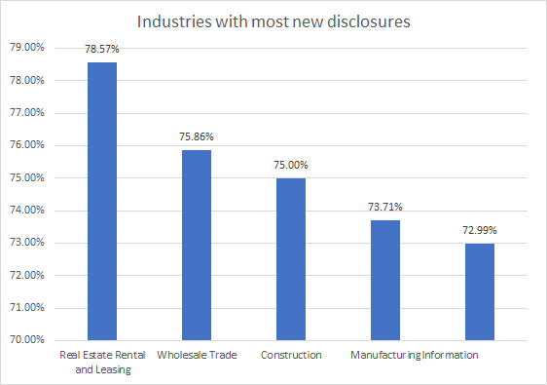

**Exhibit 2**

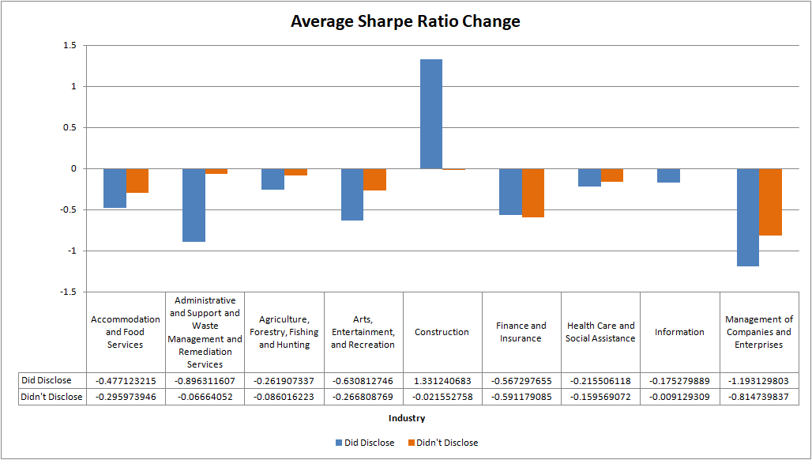

**Exhibit 2 (continued)**

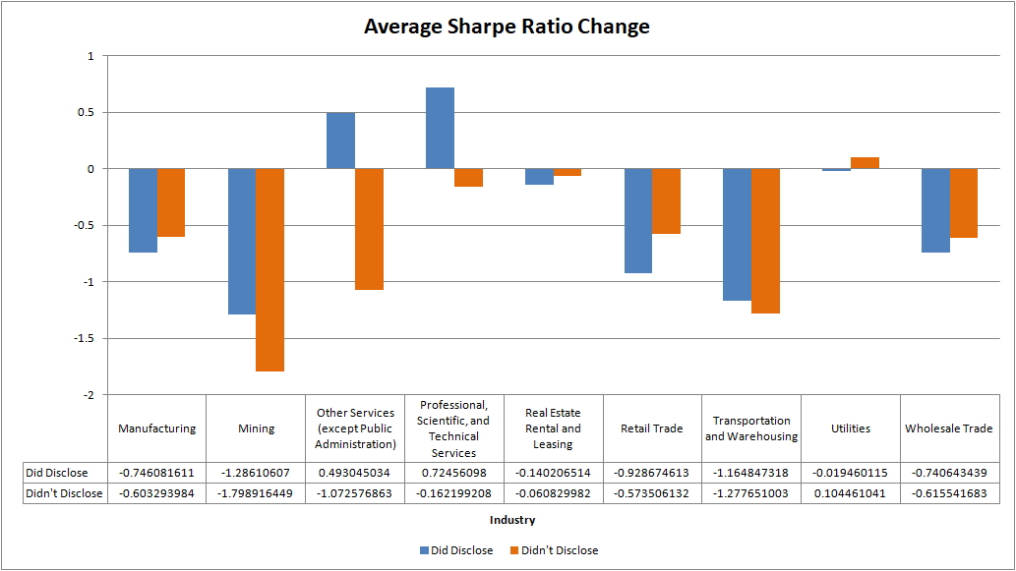

**Exhibit 3**

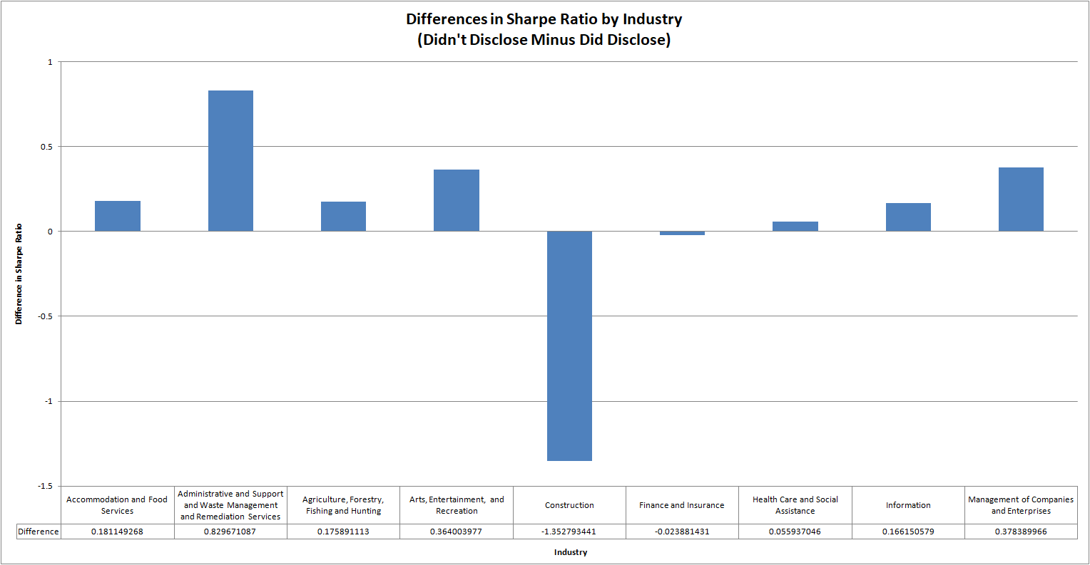

**Exhibit 3 (continued)**

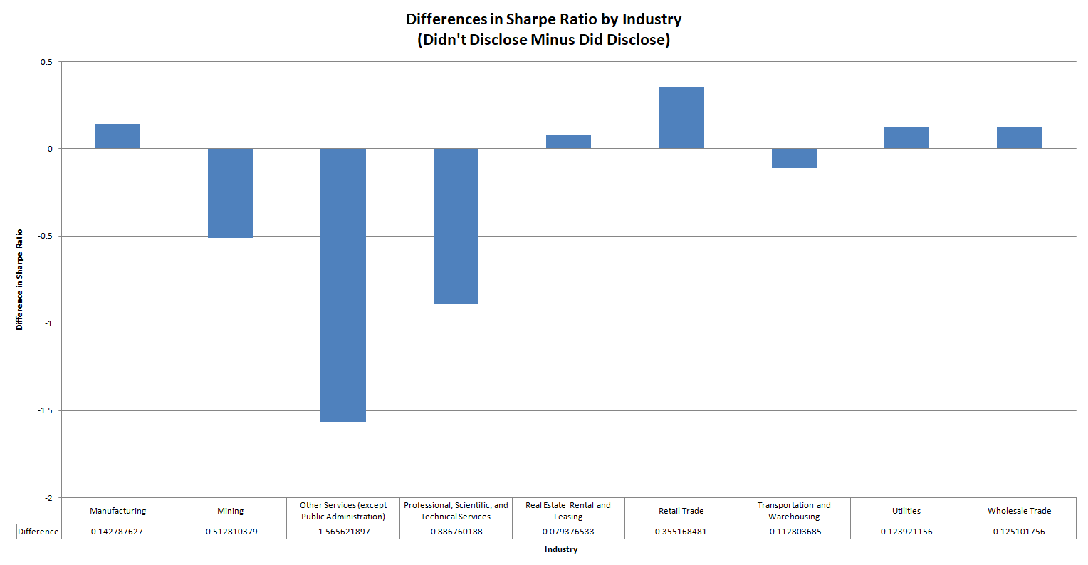

**Exhibit 4:** **Annualized Alpha difference between did and didn’t disclose stocks by industry**

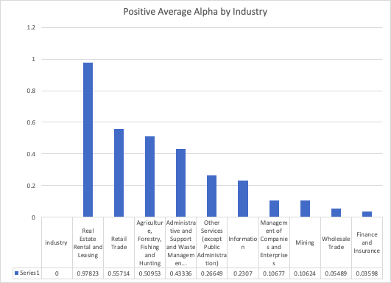

**Exhibit 5: Annualized Alpha difference between did and didn’t disclose stocks by industry**

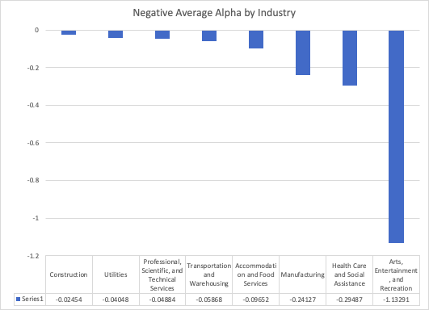

**Exhibit 6: Alpha by industry**

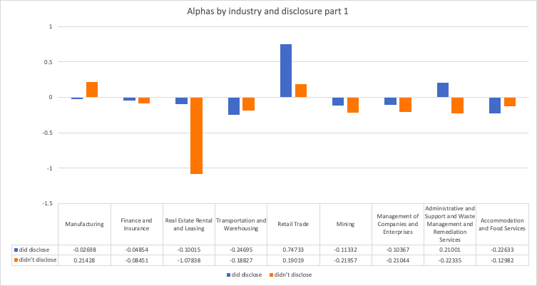

**Exhibit 7: Alpha difference by industry**

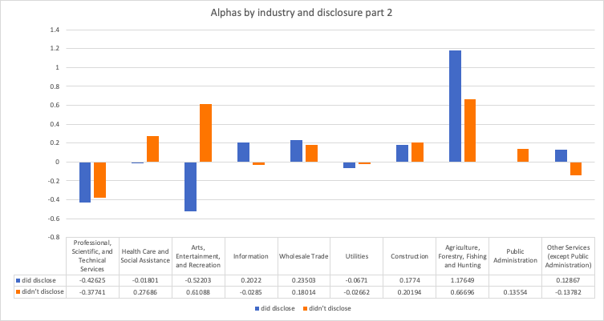

**\* Public Administration industry did not have companies that did disclose and has no basis of comparison for disclosure within industry.**

1. Excess return was calculated Re - Rf. Excess return measures how much return a stock yields over the return from a risk free security. The risk free-rate (Rf) was the 1-month TBill return from Ibbotson and Associates.
2. We began our pandemic period before the February-April stock market crash occurred, in part due to the coverage of the pandemic in financial news in January 2020. Certain investors and hedge funds placed bets on the pandemic mid February. We began the pandemic period in January to capture these price changes.
3. This calculation was made after removing two outlier companies with tickers AREC and GOVX. Four thousand and sixty four companies remained in the calculation.